**Aqueous Stability Tests**

* **Visual Cell(under 200 psi and 80 $℃$ conditions):**
  + **200 k ppm NaCl with and without 10% vol BIOS**

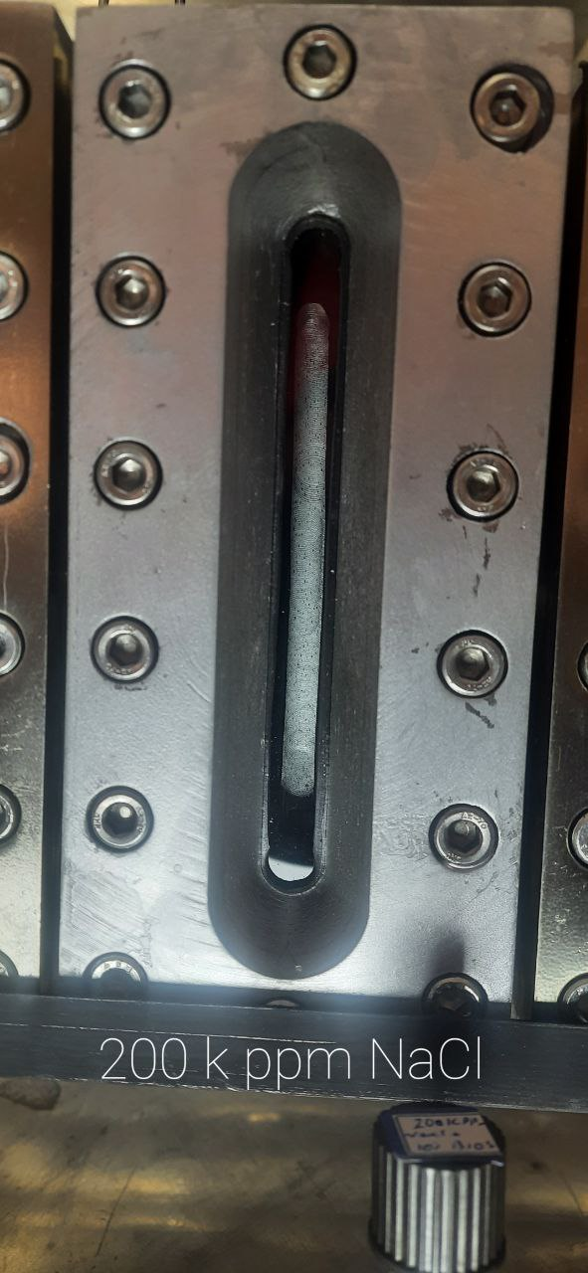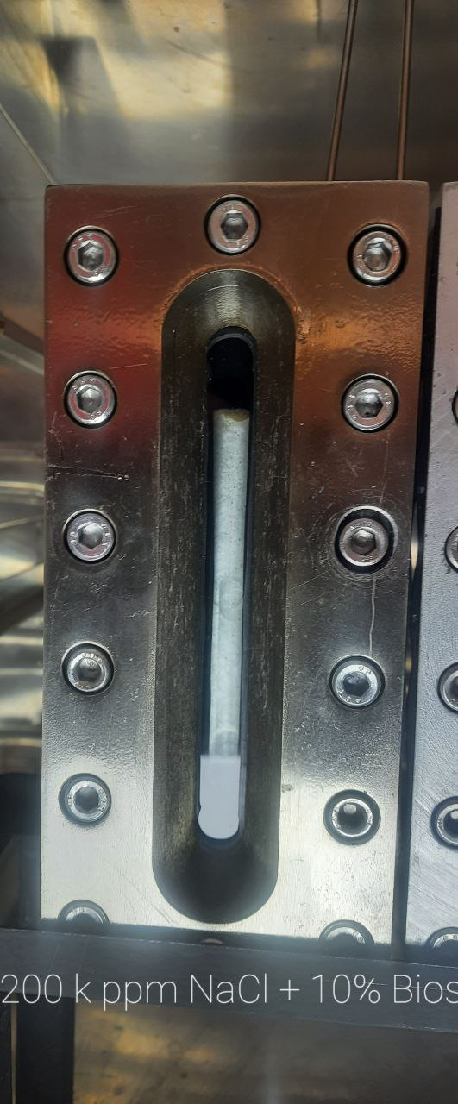

* + **100 k ppm NaCl with and without 10% vol BIOS**

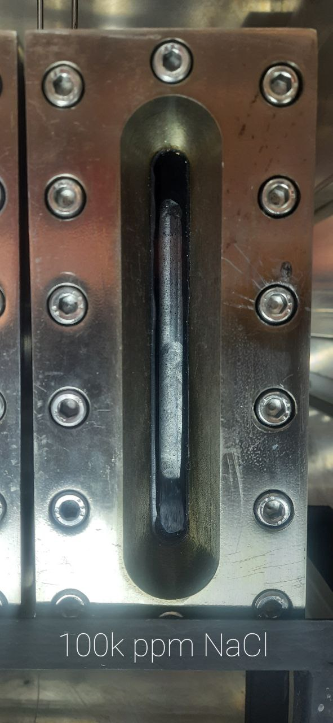

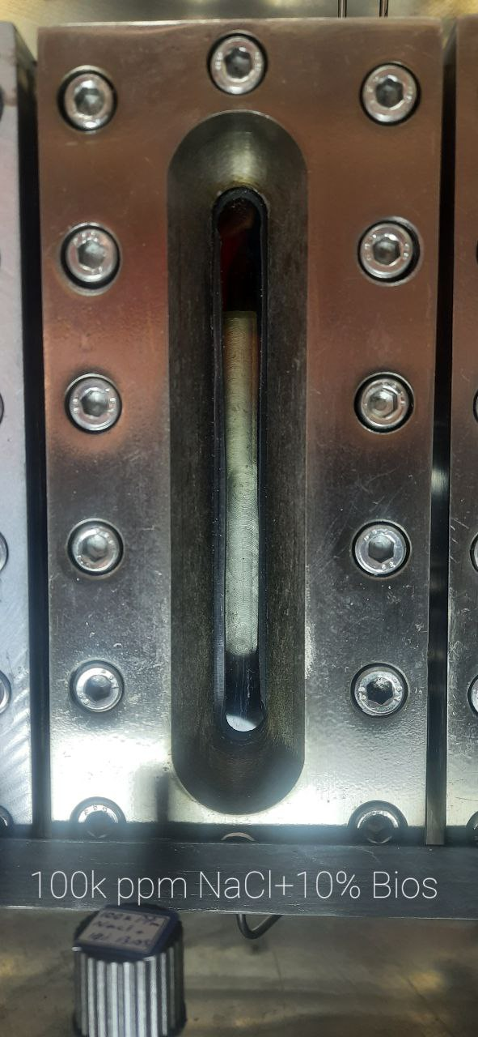

* **Glass Tube(Temperature of 80):**

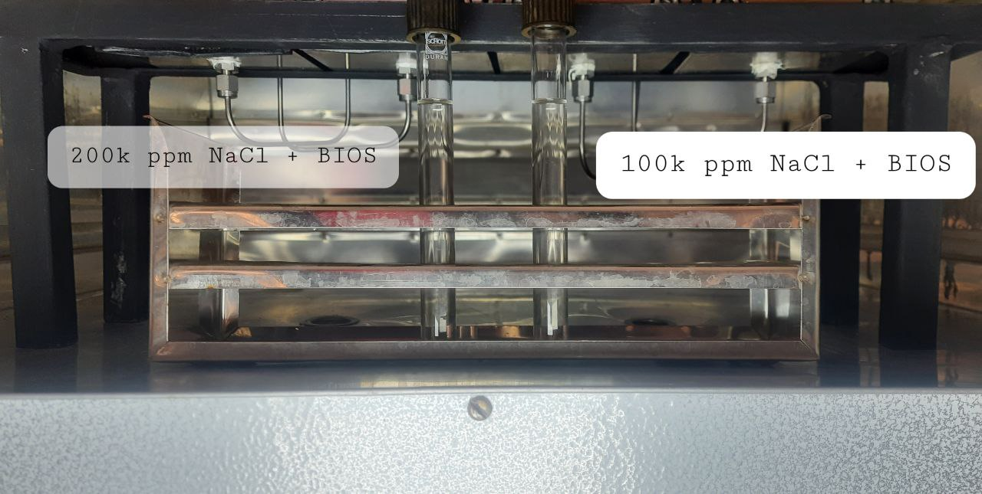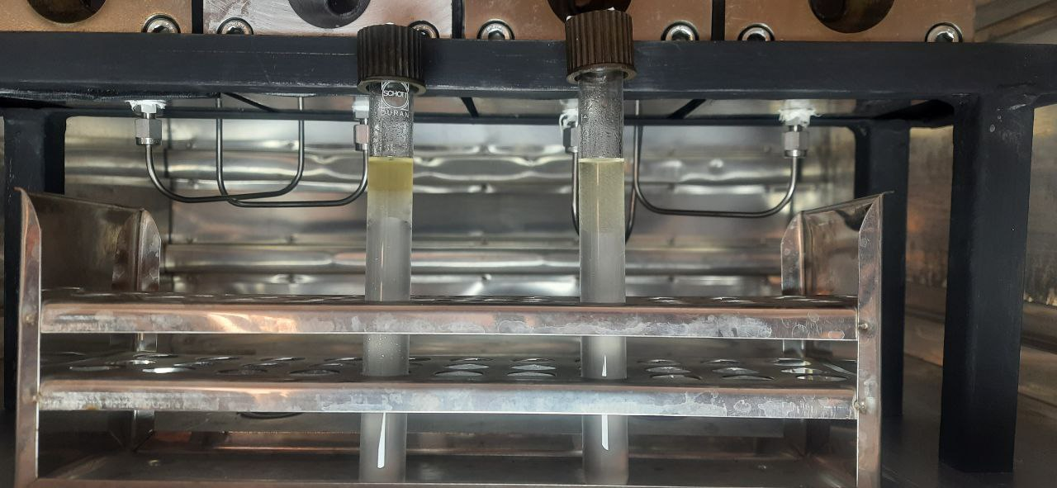

After 30 min