**Aqueous Stability Tests**

* **Visual Cell(Under 80 $℃$ Temperature):**
  + **Pure BIOS2**

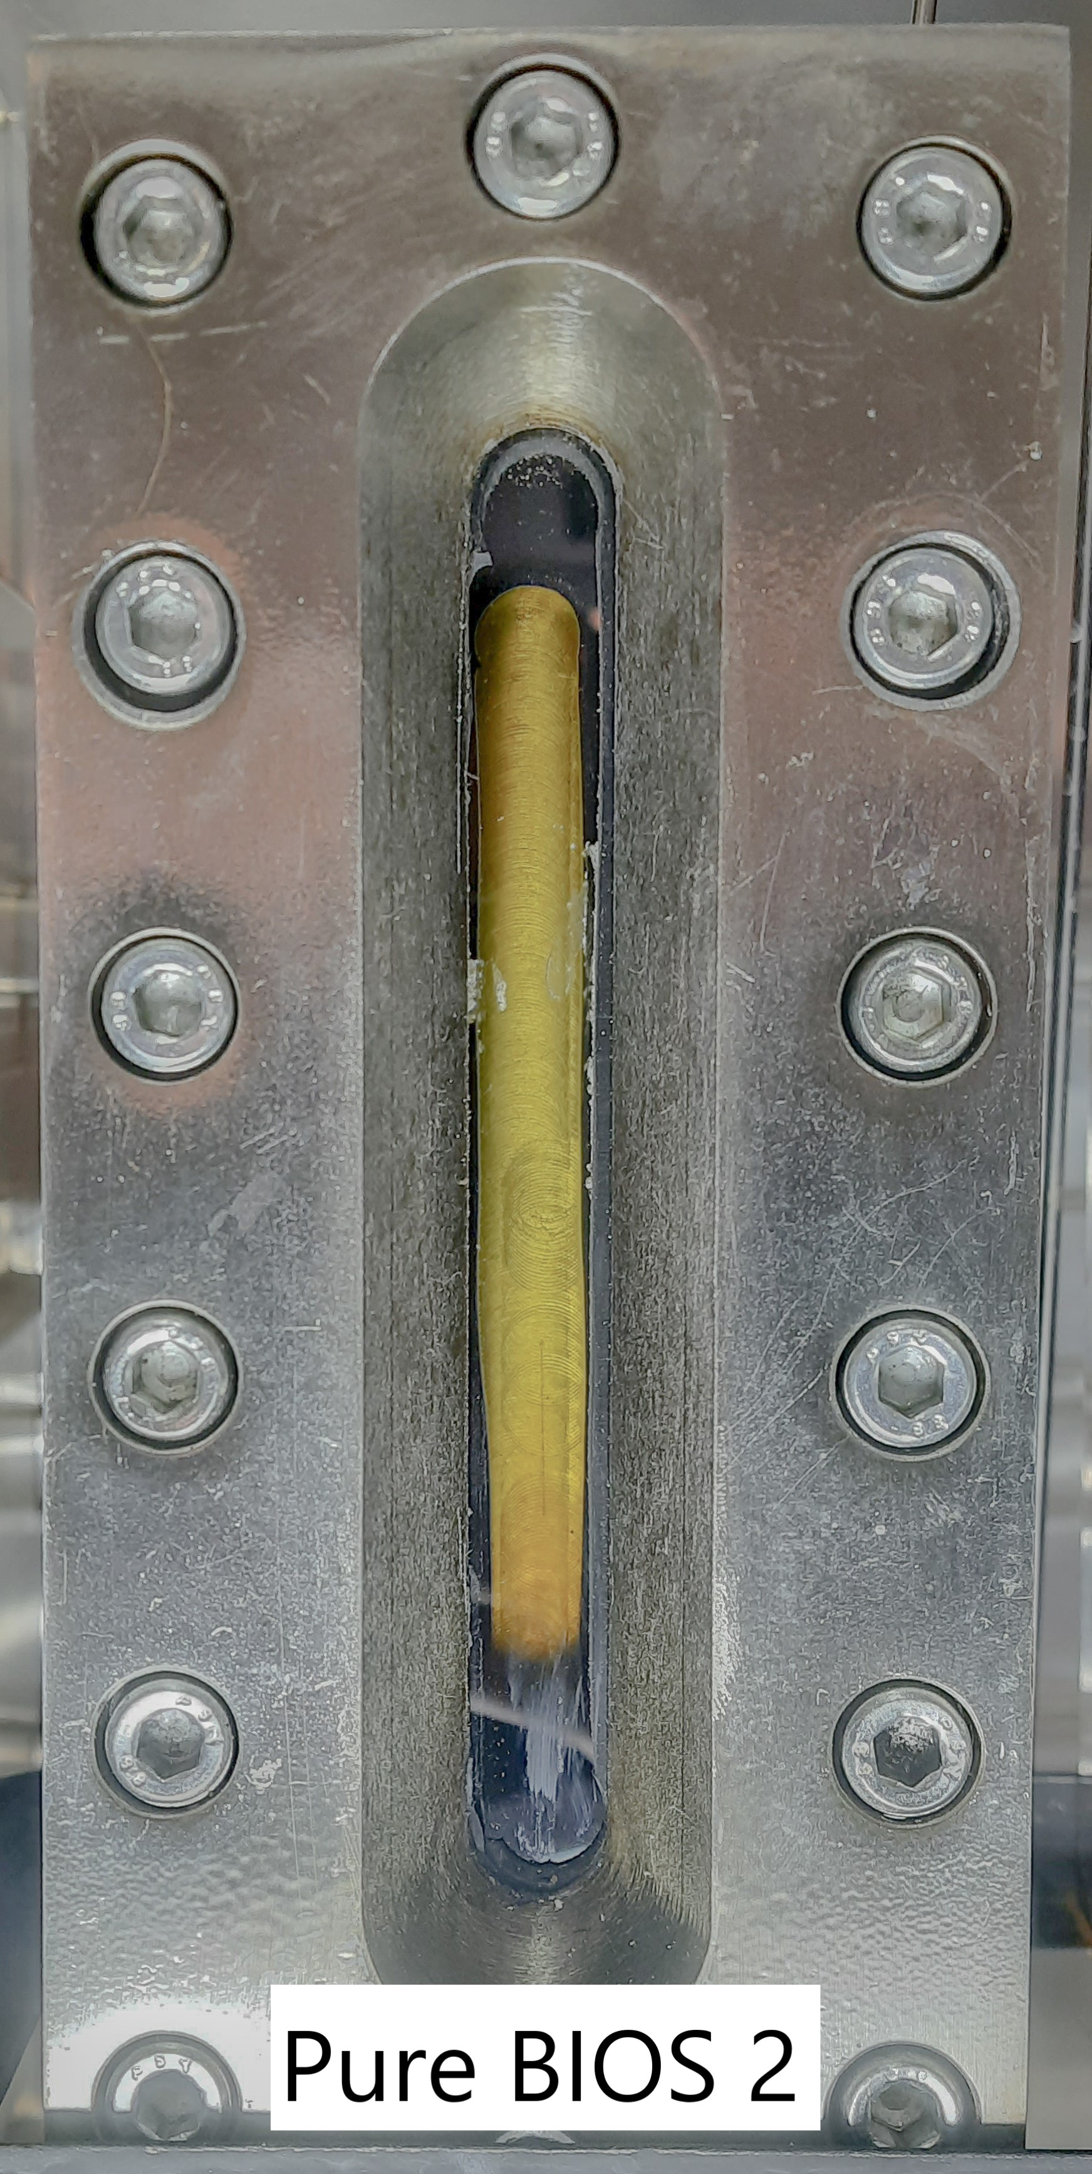

* + **BIOS2 + Crude Oil**

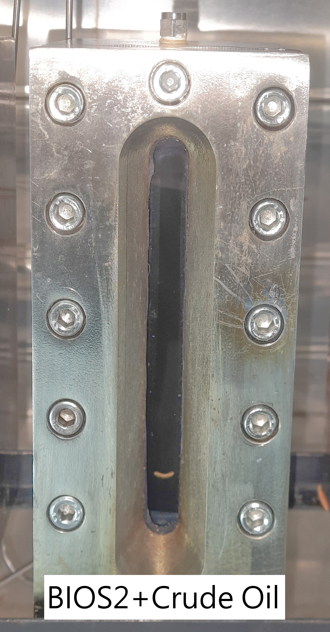

* + **BIOS2 + Crude Oil + 200k ppm NaCl Brine**

