**Aqueous Stability Tests**

* 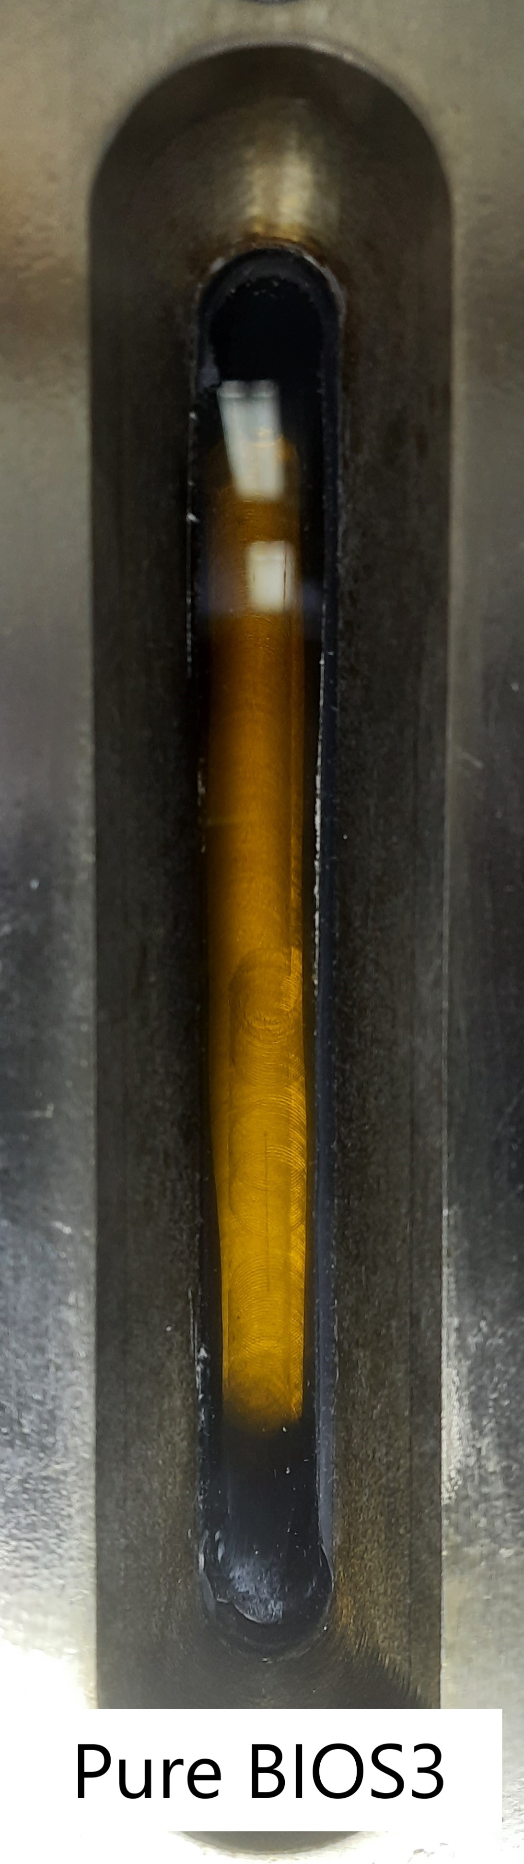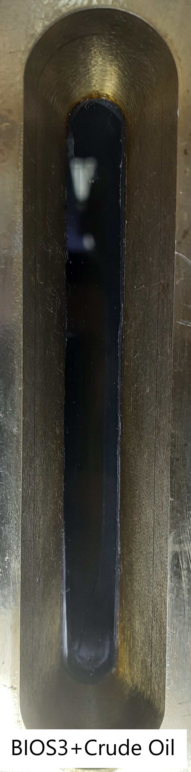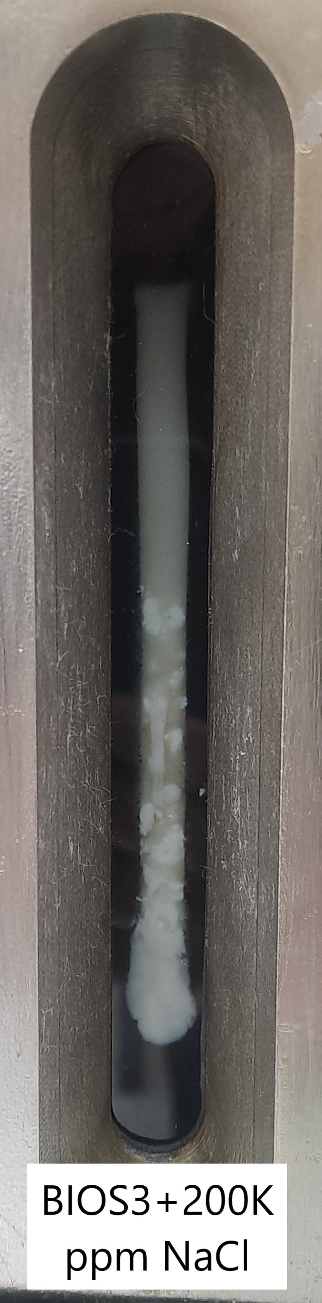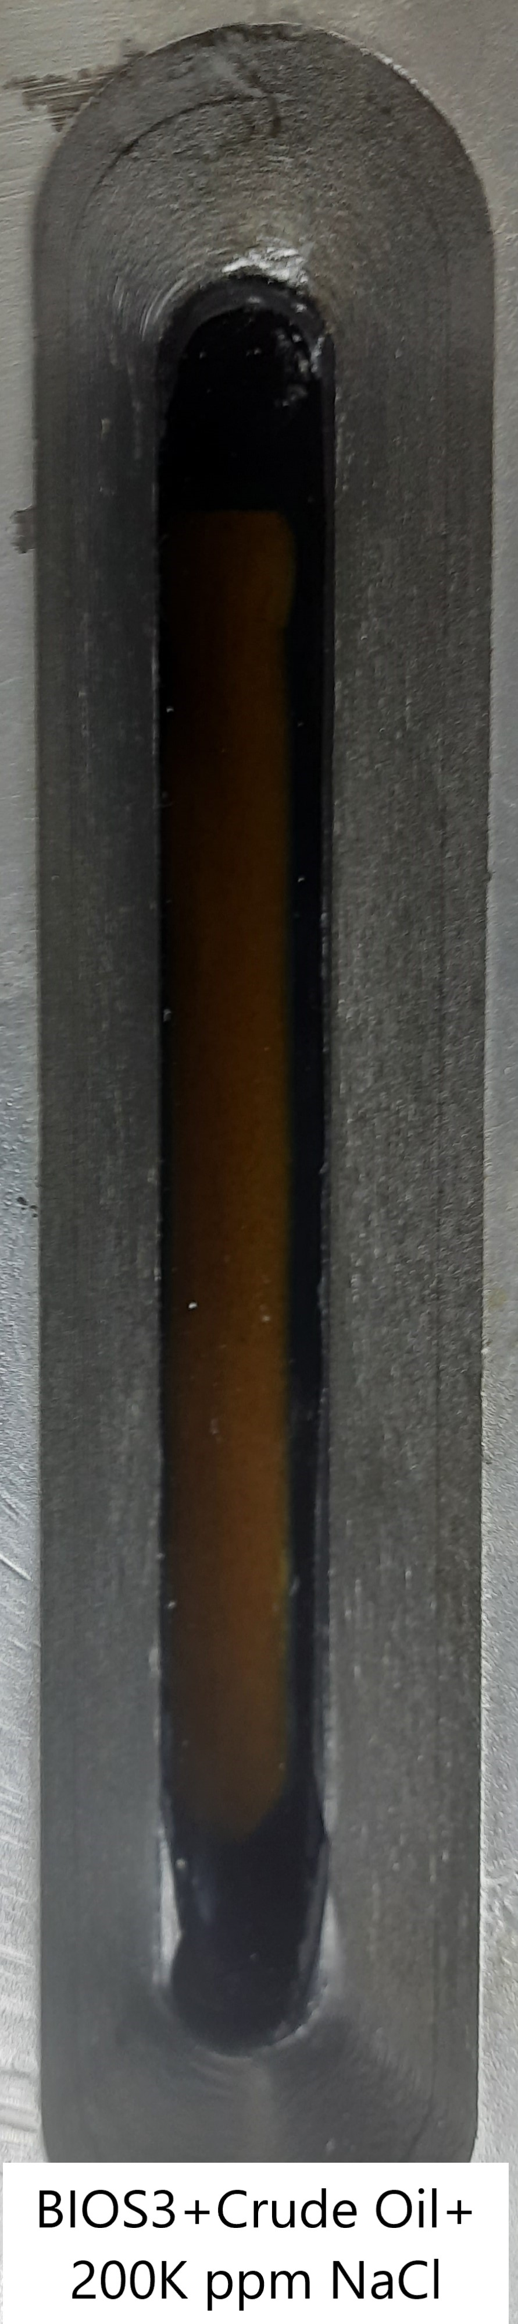**Visual Cells at First (Before Heating):**
* **Visual Cells after 2 Days ( Temperature of 80 $℃$):**

